**Problem Statement**

You are part of a team which is involved in developing an E-Commerce Website.

The E-commerce website manages its data in the Database..

1. You are required to create tables for **supplier,customer,category,product,supplier_pricing,order,rating** to store the data for the E-commerce with the schema definition given below.
2. You are required to develop SQL based programs (Queries) to facilitate the Admin team of the E-Commerce company to retrieve the data in summarized format - The Data Retrieval needs are described below.

**Table:supplier**

**Columns:**

|  |  |
| --- | --- |
| **SUPP_ID** | INT PK |
| SUPP_NAME | varchar(50) NOT NULL |
| SUPP_CITY | varchar(50)  NOT NULL |
| SUPP_PHONE | varchar(50) NOT NULL |

**Table:customer**

**Columns:**

|  |  |
| --- | --- |
| **CUS_ID** | INT PK |
| CUS_NAME | VARCHAR(20) NOT NULL |
| CUS_PHONE | VARCHAR(10) NOT NULL |
| CUS_CITY | VARCHAR(30) NOT NULL |
| CUS_GENDER | CHAR |

**Table:category**

**Columns:**

|  |  |
| --- | --- |
| **CAT_ID** | INT PK |
| CAT_NAME | VARCHAR(20) NOT NULL |

**Table:product**

**Columns:**

|  |  |
| --- | --- |
| **PRO_ID** | INT PK |
| PRO_NAME | VARCHAR(20) NOT NULL DEFAULT "Dummy" |
| PRO_DESC | VARCHAR(60) |
| **CAT_ID** | INT FK |

**Table:supplier_pricing**

**Columns:**

|  |  |
| --- | --- |
| **PRICING_ID** | INT PK |
| **PRO_ID** | INT FK |
| **SUPP_ID** | INT FK |
| SUPP_PRICE | INT DEFAULT 0 |

**Table:order**

**Columns:**

|  |  |
| --- | --- |
| ORD_ID | INT PK |
| ORD_AMOUNT | INT  NOT NULL |
| ORD_DATE | DATE  NOT NULL |
| **CUS_ID** | INT FK |
| **PRICING_ID** | INT FK |

**Table:rating**

**Columns:** **(Rating provided in this table is common for product and supplier)**

|  |  |
| --- | --- |
| **RAT_ID** | INT PK |
| **ORD_ID** | INT FK |
| RAT_RATSTARS | INT  NOT NULL |

1. Insert the following data in the table created above

Supplier Table-

**SUPP_ID SUPP_NAME SUPP_CITY SUPP_PHONE**

1 Rajesh Retails Delhi 1234567890

2 Appario Ltd. Mumbai 2589631470

3 Knome products Banglore 9785462315

4 Bansal Retails Kochi 8975463285

5 Mittal Ltd. Lucknow 7898456532

Customer Table-

**CUS_ID CUS_NAME CUS_PHONE CUS_CITY CUS_GENDER**

1 AAKASH 9999999999 DELHI M

2 AMAN 9785463215 NOIDA M

3 NEHA 9999999999 MUMBAI F

4 MEGHA 9994562399 KOLKATA F

5 PULKIT 7895999999 LUCKNOW M

Category Table-

**CAT_ID CAT_NAME**

1 BOOKS

2 GAMES

3 GROCERIES

4 ELECTRONICS

5 CLOTHES

Product Table-

**PRO_ID PRO_NAME PRO_DESC CAT_ID**

1 GTA V Windows 7 and above with i5 processor and 8GB RAM 2

2 TSHIRT SIZE-L with Black, Blue and White variations 5

3 ROG LAPTOP Windows 10 with 15inch screen, i7 processor, 1TB SSD 4

4 OATS Highly Nutritious from Nestle 3

5 HARRY POTTER Best Collection of all time by J.K Rowling 1

6 MILK 1L Toned MIlk 3

7 Boat Earphones 1.5Meter long Dolby Atmos 4

8 Jeans Stretchable Denim Jeans with various sizes and color 5

9 Project IGI compatible with windows 7 and above 2

10 Hoodie Black GUCCI for 13 yrs and above 5

11 Rich Dad Poor Dad Written by RObert Kiyosaki 1

12 Train Your Brain By Shireen Stephen 1

Supplier_pricing Table-

**PRICING_ID PRO_ID SUPP_ID SUPP_PRICE**

1 1 2 1500

2 3 5 30000

3 5 1 3000

4 2 3 2500

5 4 1 1000

6 12 2 780

7 12 4 789

8 3 1 31000

9 1 5 1450

10 4 2 999

11 7 3 549

12 7 4 529

13 6 2 105

14 6 1 99

15 2 5 2999

16 5 2 2999

Order Table-

**ORD_ID ORD_AMOUNT ORD_DATE CUS_ID PRICING_ID**

101 1500 2021-10-06 2 1

102 1000 2021-10-12 3 5

103 30000 2021-09-16 5 2

104 1500 2021-10-05 1 1

105 3000 2021-08-16 4 3

106 1450 2021-08-18 1 9

107 789 2021-09-01 3 7

108 780 2021-09-07 5 6

109 3000 2021-00-10 5 3

110 2500 2021-09-10 2 4

111 1000 2021-09-15 4 5

112 789 2021-09-16 4 7

113 31000 2021-09-16 1 8

114 1000 2021-09-16 3 5

115 3000 2021-09-16 5 3

116 99 2021-09-17 2 14

Rating table-

**RAT_ID ORD_ID RAT_RATSTARS**

1 101 4

2 102 3

3 103 1

4 104 2

5 105 4

6 106 3

7 107 4

8 108 4

9 109 3

10 110 5

11 111 3

12 112 4

13 113 2

14 114 1

15 115 1

16 116 0

**Queries →**

Write queries for the following:

1. Display the total number of customers based on gender who have placed individual orders of worth at least Rs.3000.
2. Display all the orders along with product name ordered by a customer having Customer_Id=2
3. Display the Supplier details who can supply more than one product.
4. Find the least expensive product from each category and print the table with category id, name, product name and price of the product
5. Display the Id and Name of the Product ordered after “2021-10-05”.
6. Display customer name and gender whose names start or end with character 'A'.
7. Create a stored procedure to display supplier id, name, Rating(Average rating of all the products sold by every customer) and Type_of_Service. For Type_of_Service, If rating =5, print “Excellent Service”,If rating >4 print “Good Service”, If rating >2 print “Average Service” else print “Poor Service”. Note that there should be one rating per supplier.

**Schema:**

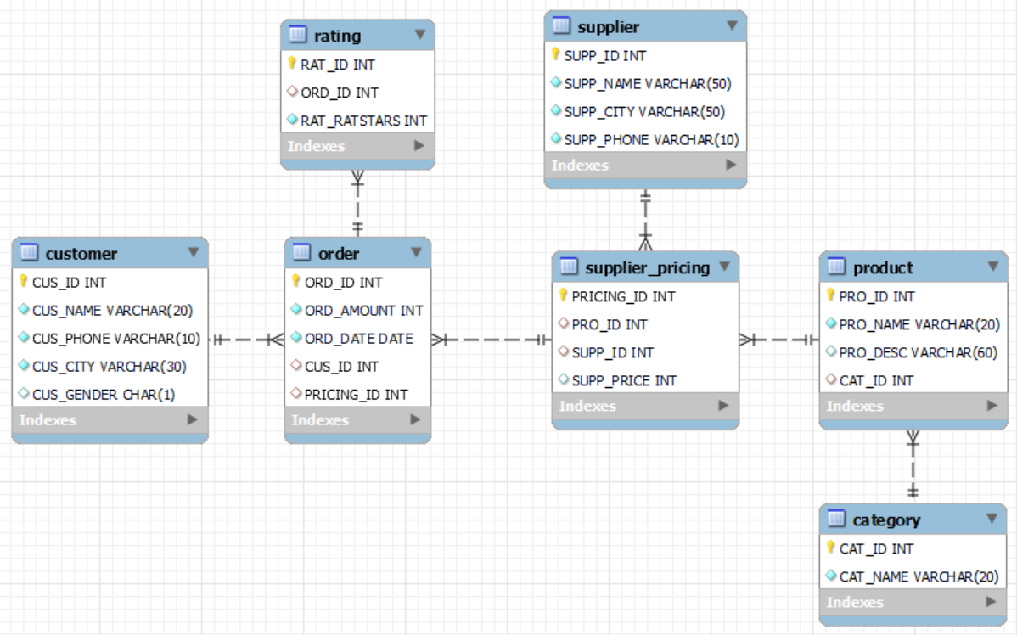

**Learning Objectives:**

After completing this project,

Learner will be able to Understand the Database Schemas for a Business Org and will be able to design the database and

corresponding tables that are needed for an e-Commerce WebSite.

Also Learner will be able to design SQL queries to retrieve data involving the following features of MySQL:

1. Select Queries (with logical & comparison operators)
2. Group By / Order By / Having Clauses
3. Joins
4. Sub Queries
5. Procedures (Creating & Executing )
6. Use case construct in a procedure.